CS 1632: Deliverable 4: Property Based Testing

Hannah Tarzian

<https://github.com/hmt17/fictional-palm-tree>

The idea behind property based testing is to create automated tests that will create many scenarios for a function and then checks the results of each to make sure they include all the required properties. It was a different way of writing a JUnit test and it had me a bit confused for a while, but they are really quite similar to any other testing approach – plug in data, run function, and check answer.

One issue I faced was with the function itself and how I wanted to write it in order to test it appropriately. I ended up saving the arrays into a List, but this caused huge issues when trying to iterate through them simultaneously. I had first set it up with two nested for loops but then realized I only needed one and once I set up the logic correctly so that it wasn’t going out of bounds of the array or list it was all running smoothly!

A confusing thing I’m not positive I figured out is my testSum() method would sometimes run in 0.000s but I know it’s running through because I placed a print line next to the assert statement to make sure it was getting to it. I included pictures of all of the tests passing in a few .0001 seconds and also them passing in 0.000 seconds. I assumed that because of the randomization in the length of the arrays caused this.

Also I couldn’t find the Eclipse folder holding my function and tests, so I just copied and pasted them into new files right on my repository, so if the TA has trouble running them please let me know! Thanks.

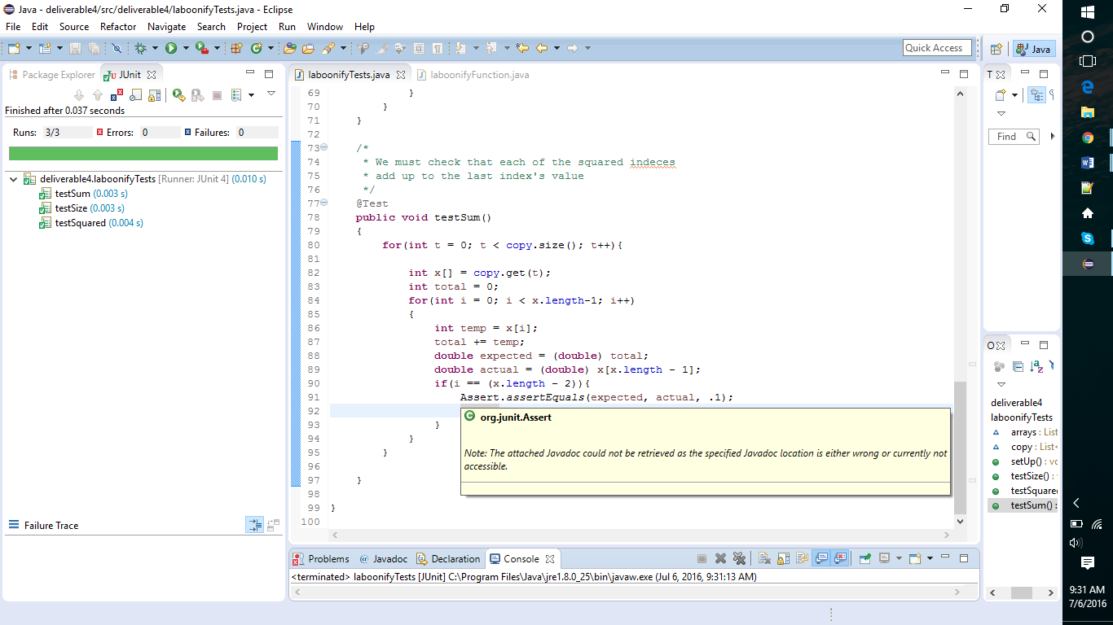

This picture shows an all tests passing but in 0.000s

